RESEARCH PROPOSAL
FOUNDERS HIGH SCHOOL
March 1, 2019
GNBS
NEXT GENERATION OF BIOMEDICAL SCIENTISTS

Research Proposal

Title: Asociation of early greying in young adults of Bulawayo with risk of hypothyroidism

Study Team: The Founders High School Science Team composed of the following members.

Students
Name |  | Surname | Class |  | Sex
Lee-Anne |  | Chazanga | Lower 6 |  | female
Siphosenkosi |  | Ncube | Lower 6 |  | female
Mercy |  | Mathe | Lower 6 |  | female
Nontobeko |  | Dube | Lower 6 |  | female
Carol |  | Chirinyu | Form 3 |  | Female
Liyanda |  | Ncube | Form 3 |  | Female
Tinashe |  | Simanga | Form 5 |  | Male
Simbarashe |  | Mandisodza | Form 5 |  | Male
Ethan | Mtinhima |  | From 3 | Male
Ngonidzashe | Rumhuma |  | Form 3 | Male

Teachers and Community Members
Name | Role | Contact
Ms S Mabota | teacher | 0772901224
L.B Bwanya | Pastor | 0773661899
Mr Dube | Male Parent | 0715631242
Ms Mawere | Female Parent | O775942449
Mayor Councilor Mguni | Mayor | 0772131767
Councilor Ruzive | Councilor(ward 6) | 0717261974
Mr Tekere | Businessman | 0712210626

Subject matter Specialists & Team Mentors
Name | Institution | Role | Contact
Dr Ranga | Ingutsheni Central Hospital | Medical Practitioner | 0773678512
Dr. Justen Manasa | AiBST | Laboratory Technologist
Ms Brillant Ngwenya | Zimbabwe National Army | Nurse | 0773011627
Prof. Collen Masimirembwa | AiBST | Project PI | 0772422951

RESEARCH QUESTION

An investigation on the implications of white hair in the development of hypothyroidism in young adults of Bulawayo.

The null hypothesis being H₀: Early greying is not a biomarker for risk of hypothyroidism.

The alternative hypothesis being H₁: Early greying is a biomarker for risk of hypothyroidism.

- RATIONALE FOR RESEARCH

The premature development of white hair is mostly genetic, is an important cause of low self-esteem, often interfering with socio-cultural adjustment. Hair colour is determined by what kind of melanin pigment is deposited in each hair shaft as it grows, but this hair-colouring process breaks down with age which is why development of white hair is associated with aging. The premature growth of white hair in young adults has been claimed to be related to autoimmune thyroid disease, hypothyroidism (Beek et al., 2008) . The gene identified for grey hair, IRF4, is known to play a role in hair colour. This gene is involved in regulating production and storage of melanin, the pigment that determines hair, skin and eye colour (Fig 1 and table 1, Adhikari et al., 2016).The T allele of rs12203592 is reported to be associated with hair colour risk for greying in America where the CC is at 86 %, the TT at 4% and the TC at 10%.

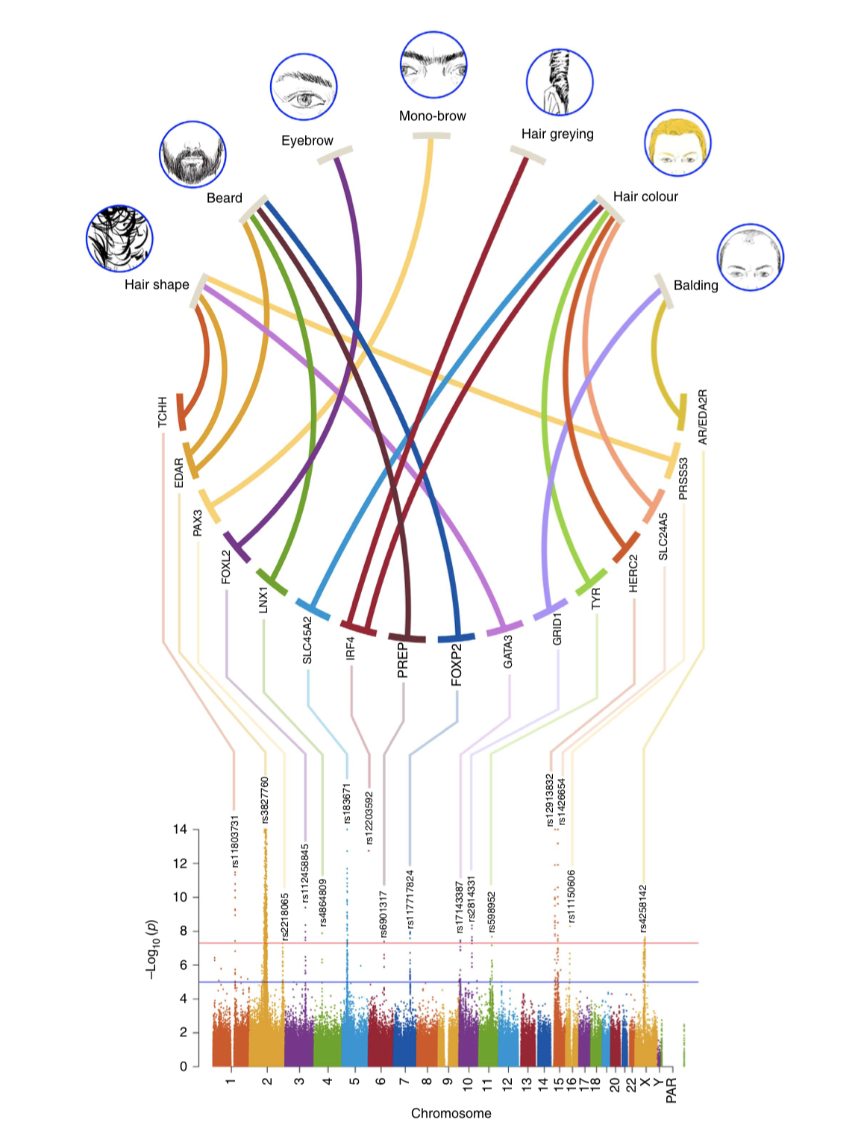

Fig 1. Signals picked from GWAS study on genes important for various hair properties.

Table 1: The specific genetic variant associated with hair properties. Special attention of this project is with rs12203592 on the IRF4 associated with hair greying.
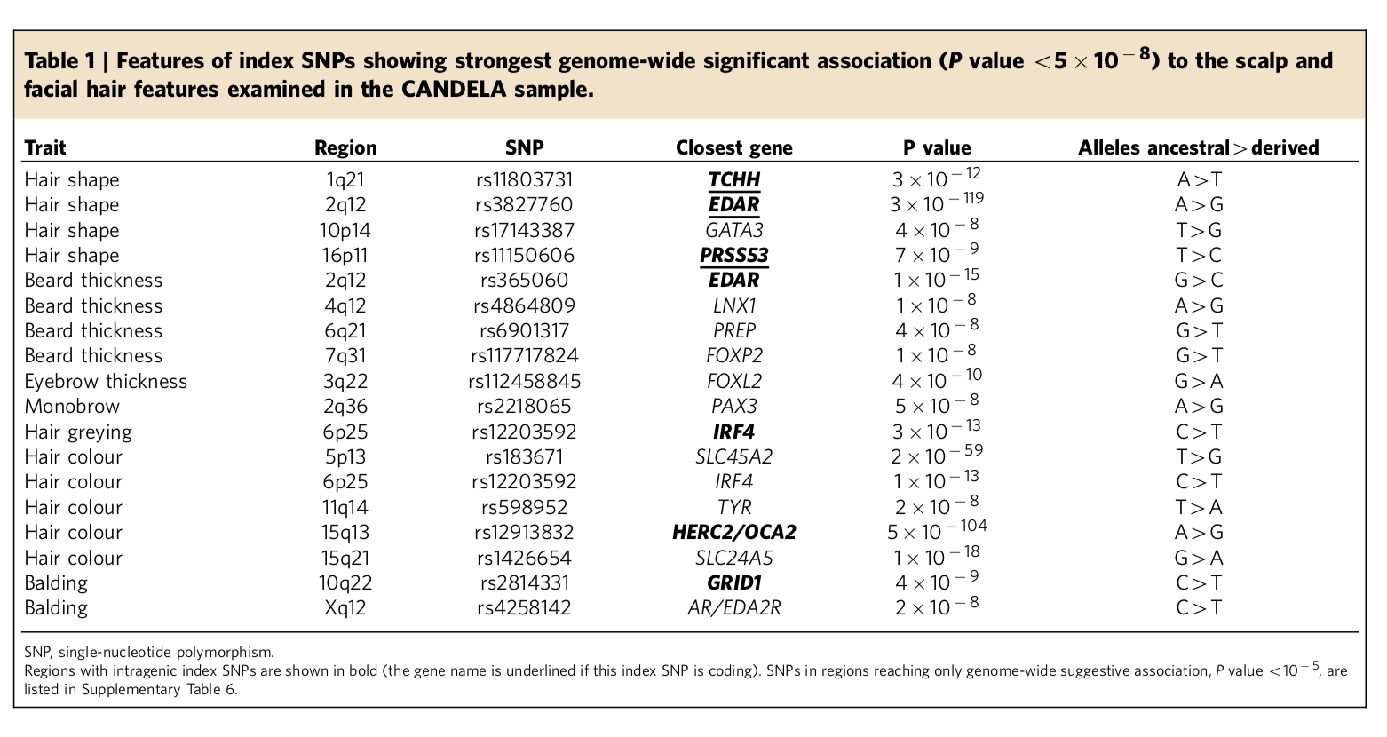
It has also been shown that Caucasians grey earlier than African Americans (ref). In Zimbabwe incidence of early greying have been reported to be xxx (ref). It is therefore important to understand the social and health implications of this early greying in our population. In particular, it will be important to evaluate the predictive value of early greying for risk of developing hypothyroidism. The study will also generate genetic variant frequency data for the Zimbabwean population.

The objectives of the research are therefore to:
- Identify 100 young adults with grey hair and 100 controls without greying. Given the exploratory nature of the study, in each group, 50 women and 50 men will be identified.
- Administer a questioner on social and health issues associated with early greying
- Collect blood for examination, for analysis of thyroid hormones for known markers for the rs12203592 IRF4 gene variant associated with greying of hair

3. METHODS

Inclusion and exclusion criteria
To answer the research question and test our hypothesis, we will conduct a set of experiments which include defining the sampling sites in Bulawayo. Previous studies have shown that whilst greying starts in the 30s for Caucasians, it starts in the 40s for people of African origin.

For increased sensitivity, for our study, individual with greying at ages under 30 will be considered as early greyer. For the control, we will take samples from people who are over 40 and are still not greyed.

Data collection
We will develop a structured questionnaire to gather data on family history on greying, life style, disease history (e.g. hypothyroidism) in the family that might be associated with early greying, social experience such as stigma, etc.

Sample collection
Genomic DNA from cases and controls will be isolated from peripheral blood lymphocytes and diluted to a final solution of 50 ng/μl. DNA concentration will be determined using the using a Nanodrop 2000 spectrophotometer. The
Genotype Analysis
The rs12203592 (T/C) assay will be ordered from Thermofisher for analysis on the Thermofisher RT_PCR, 7500. The genotyping assays will be done according to the suppliers protocol.
Thyroid Hormone analysis.
This will be done according to standard procedures (Justen to expand).l
Data Analysis
The frequency of the rs12203592 variant in the test and control volunteers will be determined and the Hardy-Weinberg Equilibrium tested. Comparison of frequencies in the control and test groups will be done using the `Chi-Squared test.
The association between the rs12203592 SNP and grey will be determined in the control and the test group.
Association of presence of the SNP and levels of thyroid hormones will also be done.

RISKS / BENEFITS TO PARTICIPANTS

There is no social, economic or legal risk to the volunteer in this study. Instead, there is benefit in them being the first to have this novel solution applied towards reducing the risk of premature greying of hair.

COSTS, COMPENSATION AND REIMBURSEMENTS
The volunteer will not be paid for their participation in the study. Travel cost reimbursement for coming to the interview and sample collection centre will however be made.

CONFIDENTIALITY ASSURANCES

The volunteers DNA samples will be kept at the AiBST Biobank and DNA database . On behalf of the Founders school. Access and use of the samples and database will be controlled by Founders School and other approved authorities. At AiBST, all Biobank samples and DNA databases are kept under strict security and confidentiality according to international guidelines for doing so.

CONFLICT OF INTEREST (real or apparent)

There is no conflict of interest in the parties involved in the conduct of this study

COLLABORATIVE AGREEMENTS

A letter of collaboration indicating the parties involved such as the Research team representative, the School, the Ministry of `Higher and tertiary Education, Science and Technology Development and the African Institute of Biomedical Science and technology.

INTENDED USE OF RESULTS

The results of this study will be communicated to the communities of Bulawayo, the Ministry of `Health, presented at national symposia and meetings. Based on the significance of the results. Intellectual property rights might be sought for by AiBST as the sponsor of the study with indicated benefits for the other participants to the study. The IP might also be translated to commercial products and services to which involved parties will be beneficiaries.

REFERENCES:
- Beek et al., 2008. Thyroid Hormones Directly Alter Human Hair Follicle Functions: Anagen Prolongation and Stimulation of Both Hair Matrix Keratinocyte Proliferation and Hair Pigmentation. The Journal of Clinical Endocrinology & Metabolism, Volume 93, Issue 11, 1 November 2008, Pages 43814388, https://doi.org/10.1210/jc.2008-0283.
- Adhikari et al., A genome-wide association scan in admixed Latin Americans identifies loci influencing facial and scalp hair features Nature Communications, 2016; 7: 10815 DOI: 10.1038/ncomms10815

